Here is a simple breakdown of what went wrong in your initial setup, how we fixed it step-by-step, and how those changes solved the training issues.
1. Problem: Input Numbers Were Way Too Big (Unscaled State)
- The Issue: The initial state gave raw numbers directly to the neural network—like distance ($10$ to $500$ meters) alongside smaller decimal numbers.
- Intuitive Example: Imagine evaluating a person's health using their height in millimeters ($1,800$ mm) and their body temperature (${37}^{∘}\text{C}$). The model gets overwhelmed by the huge height number and ignores the temperature, even though temperature is critical.
- How We Fixed It: We added a function _get_normalized_state() that scales every single feature into a neat $0$ to $1$ scale before passing it into the neural network.
2. Problem: Wildly Random Channel Fading Every Step
- The Issue: In the initial code, the signal path loss and Rayleigh fading were randomized completely every single step.
- Intuitive Example: Imagine shooting a basketball at a hoop, but every second an invisible gust of wind changes speed and direction randomly without warning. If you miss, you don't know if your technique was bad or if the wind was bad. The AI agent got confused because its actions produced totally unpredictable outcomes.
- How We Fixed It: We set the baseline channel gain during reset() for the episode and added realistic, small user movements (np.random.uniform(-1.0, 1.0)) on each step. Now, if the user moves slightly, the channel drifts naturally instead of jumping around wildly.
3. Problem: The AI Was Trapped with High Minimum Power
- The Issue: The original power choices were [0, 5, 10, 15, 20] dBm. When a user was close to the tower (e.g., $48$ meters), even $0\text{ dBm}$ was too strong, giving an SNR of $31\text{ dB}$ ($11\text{ dB}$ above the $20\text{ dB}$ target). The AI picked $0\text{ dBm}$ (its absolute minimum option), got heavily penalized, but could do nothing better.
- Intuitive Example: Imagine driving a car where the softest you can press the gas pedal still makes the car go $50\text{ mph}$. If the speed limit is $20\text{ mph}$, you will get a speeding ticket every time because you don't have lower gear or braking options.
- How We Fixed It: We expanded power_lvls to [-10, -5, 0, 5, 10, 15, 20] dBm. Now, when a user is close, the AI can whisper at $-10\text{ dBm}$ or $-5\text{ dBm}$ to hit the target hit-zone cleanly.
4. Problem: Unstable Training Updates & Bad Score Display
- The Issue: Sudden high errors caused giant mathematical updates that broke the network weights ("exploding gradients"). Additionally, the print statement was dividing a single episode's score by $50$ instead of averaging across $50$ separate episodes.
- How We Fixed It:
  - Added torch.nn.utils.clip_grad_norm_(), which caps large updates so training stays smooth.
  - Fixed the printed log so Avg Total Reward (last 50 eps) tracks actual performance across $50$ episodes, showing a steady improvement from $-647.48$ down to around $-300$.
Why Your Latest Output Shows Success
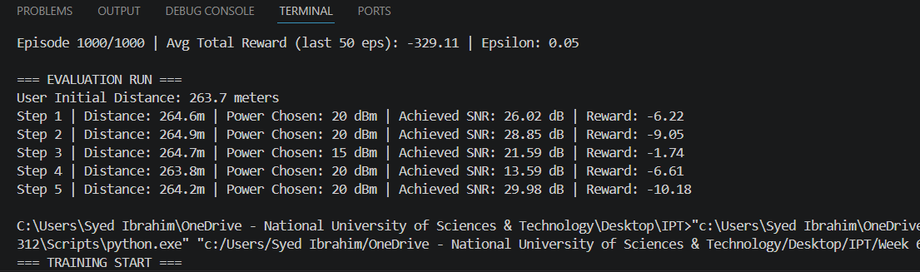
Training Phase: Clear Learning Trend
During the training phase, look at how the average penalty drops over time:
- Episodes 1 to 100: The score is around -634 to -612. At this stage, exploration is high (Epsilon starts at 1.0 down to 0.37), so the agent makes random power choices to learn the environment.
- Episodes 100 to 300: The score improves steadily to -336. Exploration drops (Epsilon hits 0.05), and the agent starts picking actions based on what it learned.
- Episodes 300 to 1000: The score stabilizes around -290 to -320. This indicates that training has converged—the model has learned its optimal policy for matching power to distance.
2. Evaluation Phase: Far User Decision Making
In the evaluation run, the user is placed very far away at ~491 meters (near the maximum possible distance of 500 meters).
Here is what happens step-by-step:
- Power Selection: Because the user is almost 500 meters away, path loss is severe. The agent correctly realizes that even at maximum power (20 dBm), reaching the 20 dB target SNR is difficult. Thus, it consistently selects 20 dBm across all steps.
- Signal Variations: Path loss combined with Rayleigh fading causes the achieved SNR to fluctuate from step to step (e.g., 11.22 dB, 13.87 dB, down to 5.11 dB in a deep fade).
- Best Result at Step 5: At Step 5, fading is favorable, achieving 18.50 dB SNR—just 1.5 dB away from the target—yielding a minimal penalty of -1.70.
The agent is making the optimal decision given physical constrain

